**USER GUID TO WAREHOUSE INVENTORY MANAGEMENT (WIM)**

**MENU:**

1. **DASHBOARD**
2. **RETURNS**

* **MANAGE RETURNS**
* **RETURN FREQUENCY**

1. **REPORTS**

* **STOCK REPORTS**
* **SHIP WISE REPORTS**
* **DATE WISE REPORTS**
* **DATE REPORT (NEW)**

1. **HISTORY**

* **VIEW HISTORY**
* **VIEW FILES**

1. **ORDERS**

* **BULK CONFIRM**

1. **SHIPMENTS**

* **VIEW DASHBOARD**
* **VIEW BACKEND**

1. **UPLOADS**

* **MANUAL (SINGLE)**
* **NEW DATA (BULK)**
* **EDIT OLD (BULK)**

1. **BARCODES**

* **GENERATE BARCODES**

1. **TOOLS**

* **VIEW DASHBOARD**
* **ONLINE IMAGE DOCX**

1. **ADMIN USER**
2. **DEVELOPER**

**DASHBOARD:**

**WHY THIS TEMPLATE:**

This template is helpful for **FULFILMENT DEPARTMENT.** They will upload the bulk file here itself, later in dashboard you can see all the shipment details.

**HOW IT WORKS:**

1. In dashboard we can see Bulk Upload and Single Upload buttons, upcoming shipment data, and we can also download the Available stock data, Unavailable Stock data, Complete data.

2. Available stock means the stock which is available in our warehouse.

3. Unavailable stock means the stock which is not available in our warehouse.

4. In search bar we can search any ASIN details and below we can see the total result.

5. In some cases the fulfilment team will manually update the “Availability” field.

6. Bulk upload is used upload the bulk data to project all the data on dashboard.

**HOW TO USE BULK UPLOAD:**

**Step1:** Open Warehouse dashboard there you can see the bulk upload button.

**Step2:** Now click the bulk upload button, then you can see the interface of it as shown in below image.

**Step3:** Click of\n Download Template, here the excel sheet will download.

**Step4:** Fill the data according to the shipment sheet.

**Step5:** Upload this downloaded file in chose file and click submit.

Step6: There is one more option **Update Data** this is used to update any fields except ASIN.

Step7: To update this first click on download template in Update Data.

Step9: Now the excel sheet will downloads, here based on product PUID we must do update.

Step10: Now upload the updated file by clicking on choose file and click submit.

**RETURNS:**

In returns we have 2 options one is **MANAGE RETURNS** and another one is **RETURN FREQUENCY.**

**MANAGE RETURNS:**

**WHY THIS TEMPLATE:**

This template is helpful for **FULFILMENT DEPARTMENT.** They used to manage the returns and update the product status based on the conditions.

The above image is for **MANGE RETURNS.**

**HOW IT WORKS:**

1. The fulfilment team will deal with this returns template, after getting the returns they provide product id or order id or ASIN or PUID in input filed.
2. Now they get the total information on that product, based on the return product condition they will update the “Availability field”.
3. If it’s good, then they will update it as RESTOCK if product is fake then they will update it as fake and if the product got used and it looks with multiple scratches then they update it as “Add to bin”.
4. This is about MANAGE RETURNS.

**HOW TO USE:**

**Step1:** Open Warehouse and click on side menu, move to returns and click on it, there you can see 2 sub-options one is MANAGE RETURNS another one is RETURN FREQUENCY.

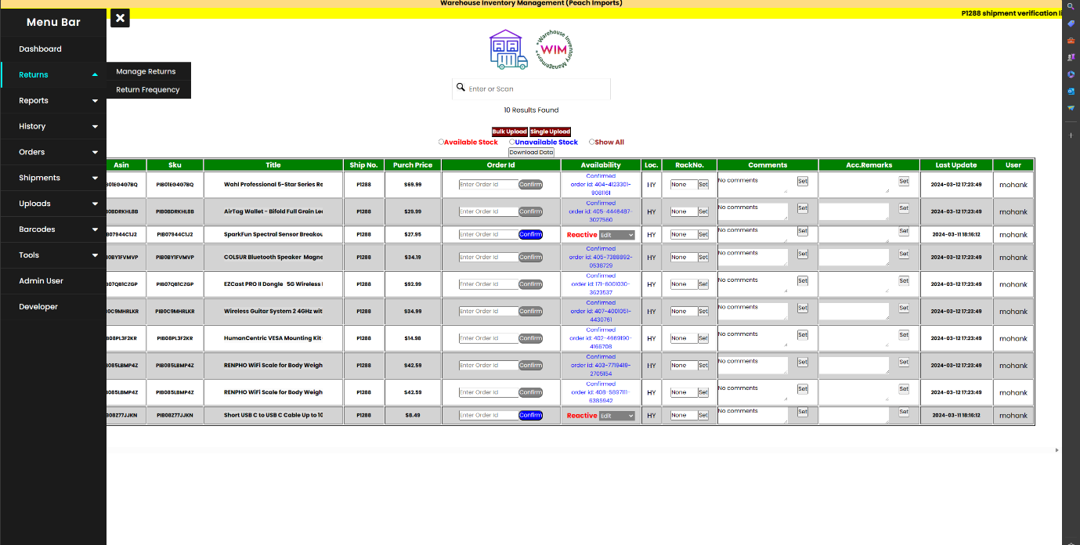

**Step2:** Click on MANAGE RETURNS and there you can see the input filed, in that field provide order id it will show the complete information of that returned product.

**Step3:** Now fulfilment team will check the product physically and base on the product condition they will update the “Availability field”

**RETURN FREQUENCY:**

**WHY THIS TEMPLATE:**

This template is helpful for **FULFILMENT DEPARTMENT.** They used to check the product return count and if the count got repeated multiple times, then it will directly move to BIN.

The above image is for **RETURN FREQUENCY**

**HOW IT WORKS:**

1. This template is used to check the count of product return.
2. The fulfilment team will deal with this return’s frequency template. They provide product id or order id or ASIN or PUID in input filed.
3. To check the count of product got returned.
4. If the product got returned multiple times, then it will move to “bin”.

**HOW TO USE:**

**Step1:** Open Warehouse and click on side menu, move to returns and click on it, there you can see 2 sub-options one is MANAGE RETURNS another one is RETURN FREQUENCY.

**Step2:** Click on RETURN FREQUENCY and there you can see the input filed in that field provide order id it will show the complete information of that returned product.

**Step3:** Now the operation team will check the product and when it crosses the return count then it will move to “BIN”. The return count should be 0, but if the product gets return more than 2 times then they will consider that product is unsellable product.

**ORDERS:**

**Bulk Confirm**

**WHY THIS TEMPLATE:**

This template is helpful for **FULFILMENT DEPARTMENT.** They used this template to upload the order list data to confirm the orders in BULK.

**HOW IT WORKS:**

1. In this Bulk Confirm template, after order verification they will download the template and after downloading it shows an excel sheet.
2. In that they will fill the data from order confirm sheet into new downloaded sheet in the fields of ASIN, Order id, Quantity, Shipment number, Order type.
3. And they save that file and that file they will upload into bulk confirmation template, now in backend code will automatically confirm the orders where it changes the status Reactive into order confirmed with order id.

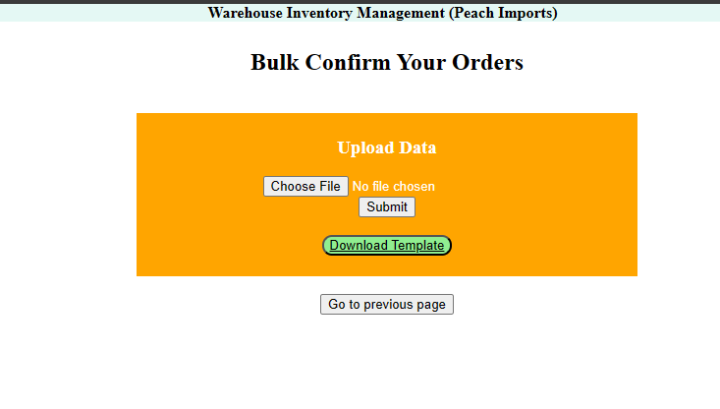

This is the bulk confirmation template.

1. Before using this template, the operation team will do the confirmation in manually then it took lot of time to confirm the orders, because the order count will be more than 200.
2. So, after introducing this bulk confirmation template, it will automatically do the order confirmation.
3. Before order confirmation, the template will cross check the order confirmation sheet if all the criteria will satisfy then only the orders will be confirmed.
4. CRITERIA: All the ASINS, product title, and order verification sheet and shipment sheet should merge.
5. If in cases the ordered ASIN and offer ASIN will miss match, then fulfilment team will update it manually in dashboard.

**HOW TO USE:**

**Step1:** Open Warehouse and click on side menu, move to Orders, and click on it, there you can see an option: Bulk Confirm.

**Step2:** Click on the Bulk Confirm and you can see the bulk confirmation templates as shown in above image.

**Step3:** Now click on download template, it downloads one excel sheet.

**Step4:** Here you can see the required fields in above image, now fill that fields where the data available in order verification sheet and save the file.

**Step5:** Now open template and click on choose file and upload the saved file.

**Step6:** Now the code runs and confirm the orders in bulk.

**SHIPMENTS:**

**View Dashboard**

**WHY THIS TEMPLATE:**

This template is helpful for **WAREHOUSE DEPARTMENT.** They used this template to confirm and check the products by comparing the received products and ordered products.

**HOW IT WORKS:**

1. In this Shipments there are 2 options one is **“View Dashboard**”, and another one is “**View Backend**”.
2. Here in this **“View Dashboard”** when there is new shipment then they will request for new link.

This is the request new link template image.

1. After once the link is generated, through the link the warehouse department will check all the delivered products.
2. If received product matches to ordered product then they will do Inbound.
3. And if the order available then they will Outbound that product
4. Before outbound they should download the air waybill and invoice bill without those bills, they can’t outbound the product.
5. To download those both air way and invoice bill first **OPERATION TEAM** will upload the merged air way and invoice bill pdf file in backend template.
6. After completing the outbound process, the product delivers to customer.

**HOW TO USE:**

**Step1:** Open Warehouse and click on side menu, move to Shipments, and click on it, there you can see two options one is View Dashboard; another one is View Backend.

**Step2:** Click on **“View Dashboard”** now you see the shipment verification dashboard.

**Step3:** Click on **“Request New Link”** it shows you **“Shipment Verification Link Request form”** template.

**Step4:** Fill the input fields and click on submit.

**Step5:** Now the new link will generate with the shipment id.



**Step6:** After clicking on new link, alert box will appear and ask your name to identify who is operating that template. So, enter your name.

**Step7:** Now check the product with ASIN or TITLE, if details match bubble it, then it turns into black colour that means the product was matched and verified.

**Step8:**  Now click on **“check Orders”** if there are no orders to both PEACH and BLUMAPLE then empty table will appears as shown in below image.

**Step9:** Now click the next product **“check order”** button if the order is there for **PEACH,** then table data shows to peach if it’s there for **BLUMAPLE** then according to that it shows the table data as shown in below image.

Here you can see the order is there for **PEACH** and **BLUMAPLE** is empty.

**Step10:** Now click on **“print AWB”** and **“print invoice”,** it shows you the airway and invoice bill’s if the operation team uploads the merged file in backend.

**Step11:** After clicking on **“print AWB”** and **“print invoice”**, if the bills consist of then you can see the bills as shown in the below images.

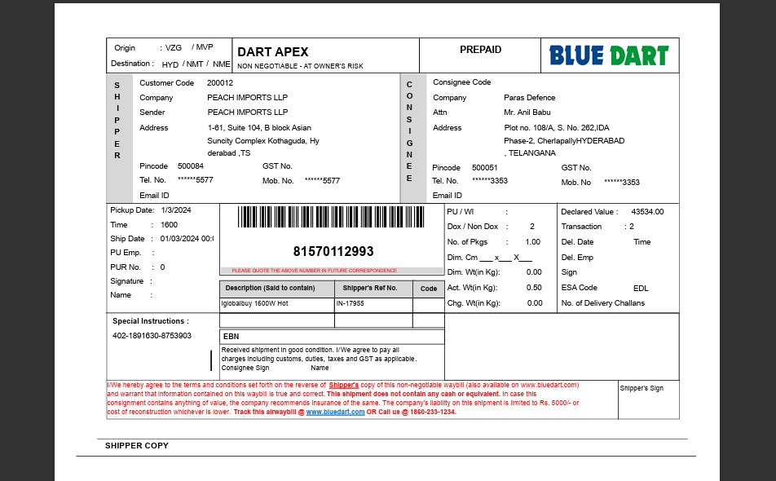

This is Air Waybill.

This is Invoice bill.

**Step12:** Now click on “done” to do outbound. And the product will deliver to customer.

**View Backend**

**NOTE:** We are not using this View Backend, to upload the files in backend we are using in “VIEW DASHBOARD” and in that you can see **“Upload Backend Files”** as show in below image.

Here we are uploading directly.

**WHY THIS BACKEND TEMPLATE**:

We must print the air waybill and invoice bill after product verification.

To print those bills here, we must upload the files in backend.

**HOW IT WORKS**:

Afte uploading the merge file the pdf will moves to shipment order details page, there when we click on invoice and airway bill then the bills will visible.

**HOW TO USE:**

**Step1:** Open Warehouse and click on side menu, move to Shipments, and click on it, there you can see two options one is View Dashboard; another one is View Backend.

**Step2:** Click on “View Dashboard” now you see the shipment verification dashboard.

**Step3:** Click on “Request New Link” it shows you “Shipment Verification Link Request form” template.

**Step4:** Click on “Backend Files” then you can see Backend Data Files Management Page.

**Step5:** Click on choose file and upload the bulk merge file.

In this image we can see both air waybill and invoice bill are merged into one pdf.

**Step6:** Give all the order id in second input filed.

**Step7:** Give all the tracking id in third input filed and click upload.

**Step8:** Now successfully file got uploaded and all the bills will be available to take print.

**Step9:** In second division you can see the search your files here, this field helps you to find the file was uploaded or not.